Brecha, et al. – Ocean Thermal Energy Conversion - Flexible Support Technology for 100% Renewable Energy Systems in the Caribbean

Supplementary Information

**Part I – GIS mapping details and procedure outline**

Maps with layers are available to view publicly at xxx

*Data sources*

For the bathymetry data:

Reference: <https://www.gebco.net/data_and_products/gridded_bathymetry_data/#a1>

<https://www.gebco.net/data_and_products/gridded_bathymetry_data/gebco_2020/>

**GEBCO Compilation Group (2020) GEBCO 2020 Grid (doi:10.5285/a29c5465-b138-234d-e053-6c86abc040b9)**

Cell resolution: 15 arc seconds (GRID cell size range in meters: 383.5m (N) -> 458.25m (S)

Coordinate System: WGS 1984

Extent (see below)

GEBCO operates under the International Hydrographic Organization (IHO) and the Intergovernmental Oceanographic Commission (IOC) (of UNESCO)

For the coastline data:

NOAA Coastlines Shapefile: <https://www.ngdc.noaa.gov/mgg/shorelines/>

Wessel, P., and W. H. F. Smith (1996), A global, self-consistent, hierarchical, high-resolution shoreline database, J. Geophys. Res., 101(B4), 8741–8743, [doi:10.1029/96JB00104.](https://doi.org/10.1029/96JB00104)

Coordinate System: WGS 1984

Projected Coordinate System: Equidistant Conic, NAD 1983 (see below for screen shot of modifications for Caribbean study area)

Extent: Matched GEBCO dataset

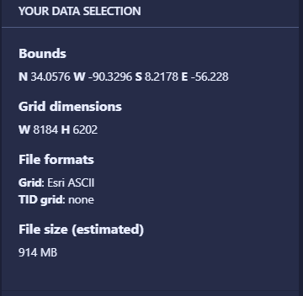*Procedure notes:*

1. Downloaded Caribbean region (see download screen capture) – clip can be to any exact extent wanted. Download format: Esri ASCII for use with ArcGIS Pro (Import as Esri GRID file)
2. Display GEBCO GRID in ArcGIS Pro
3. Extracted all values < -1000m
   1. Convert to poly (will also use to extract all areas >5km from coastline)
   2. Overlay on basemap with detailed coastline/land layer (extracted to same extent)
   3. Bright blue areas all depths > -1000m

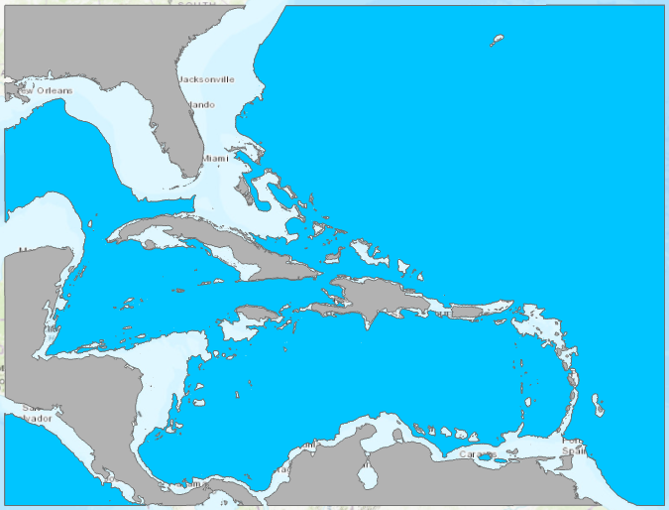

1. 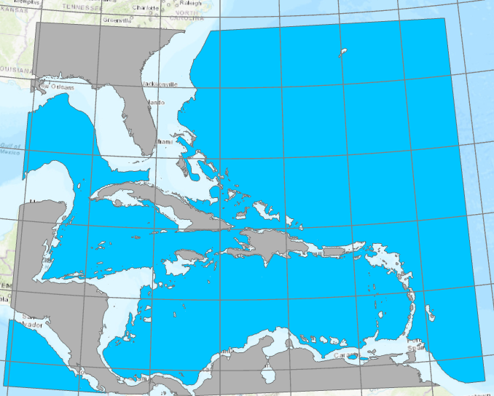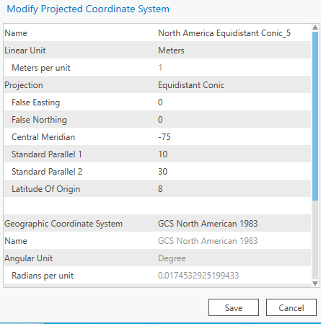Projected coastline/land feature class (horizontal datum in meters) for region.  
   Modified Equidistant Conic:
2. Create four buffers from coastline/land layer
3. < 2.5km
4. 2.5km – 5.0km
5. 5.0km – 7.5km
6. 7.5km – 10km
7. kept as separate feature classes for ease of display and future analysis
8. extracted buffer areas with ocean depth areas greater than 1000m

**Part II – Results of mapping and preliminary site selection**

Table SI2 summarizes several of the locations with promising OTEC resources in the Caribbean. Static maps of these islands are shown below; the maps with layers as defined in the main text can be viewed interactively at <https://arcg.is/11vrHe> .

|  |  |  |
| --- | --- | --- |
| Jamaica | *Western* | Negril (hotels, airport) |
| *Northwestern* | Lucea |
| *Northwestern* | Montego Bay |
| *Southeast* | East of Kingston |
|  |  |  |
| Grand Cayman | *All areas* | George Town, Bodden Town, East End, West Bay |
|  |  |  |
| Cuba | *Southeast* | Santiago de Cuba |
| *Northeast* | Guardalavaca (tourist resorts) |
| *Northeast* | Playa Uvero, Playa La Playita (tourist resorts) |
| *Northeast* | Havana |
|  |  |  |
| Bahamas | *Central* | Nassau |
| Turks and Caicos Islands | *East* | Cockburn Town |
| Haiti | *West* | Canal de St.-Marc, Canal de la Gonâve |
| Dominican Republic | *South* | Barahona, Paraíso, Los Patos |
| Puerto Rico | *Southeast* | Guayama |
| Guadeloupe | *Northeast* | Le Moule |
| Dominica | *West coast* | Roseau, Portsmouth |
| Martinique | *West coast* | Fort-de-France, St Pierre |
| St Lucia | *Southwest* | Soufriére |
| St Vincent and the Grenadines | *West coast* | Kingstown |

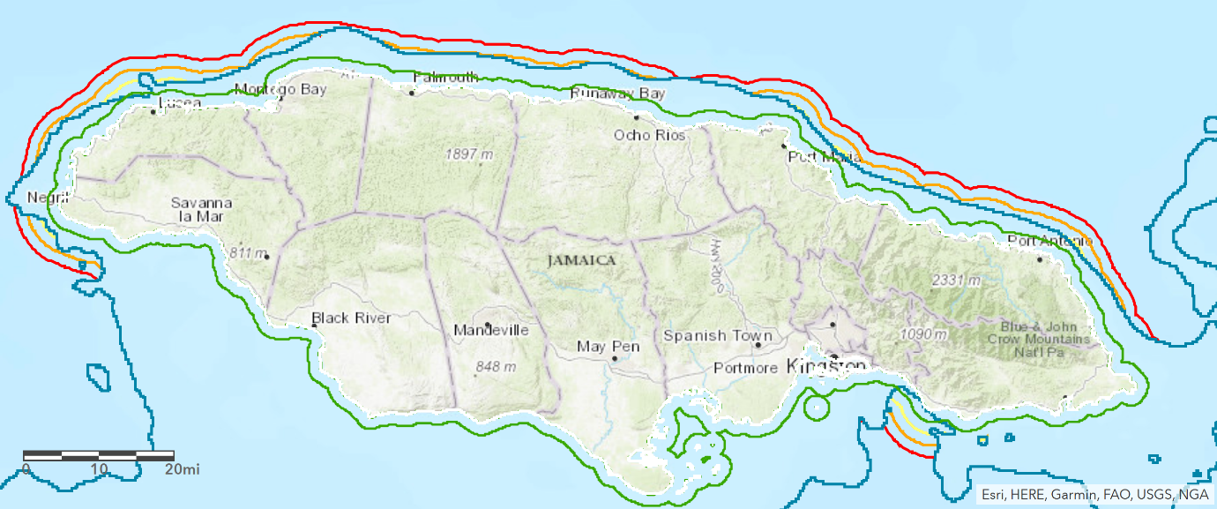

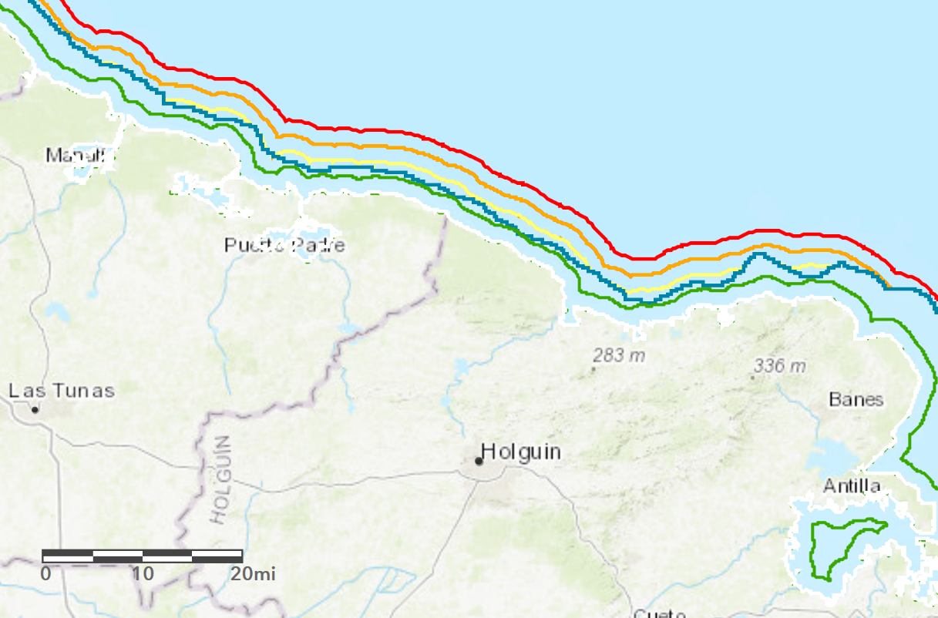

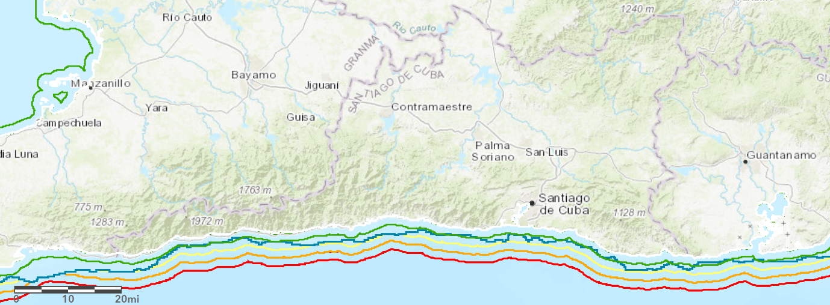

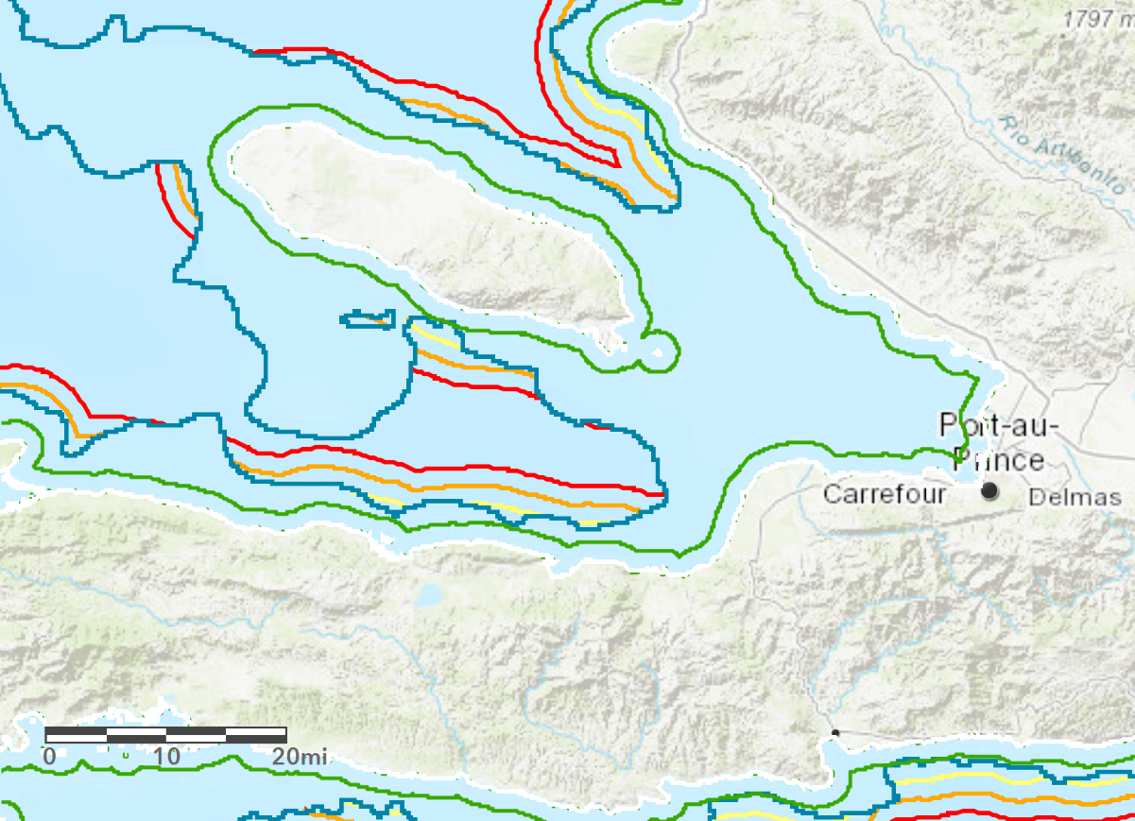

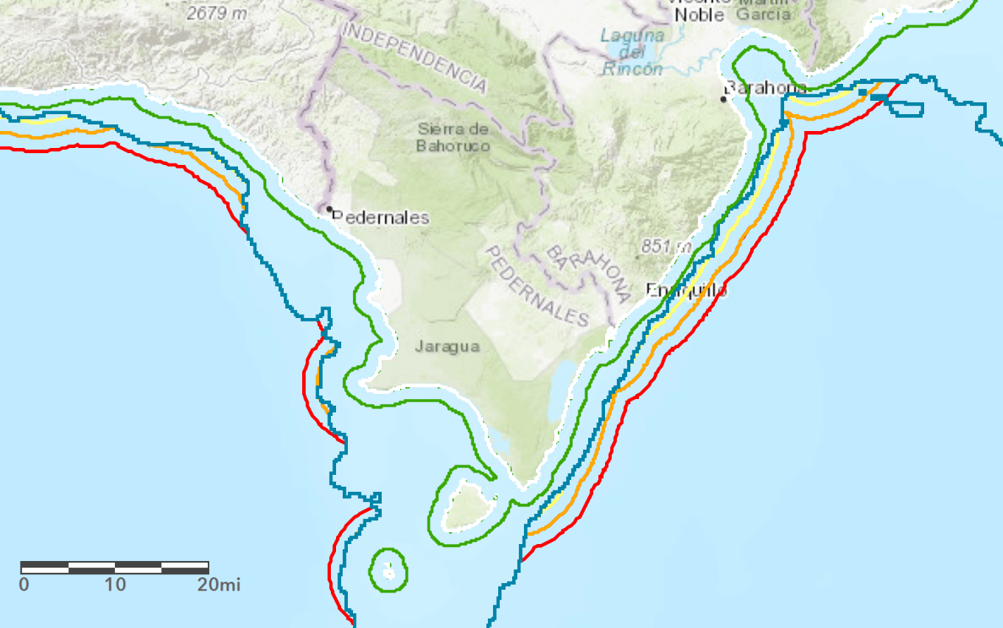

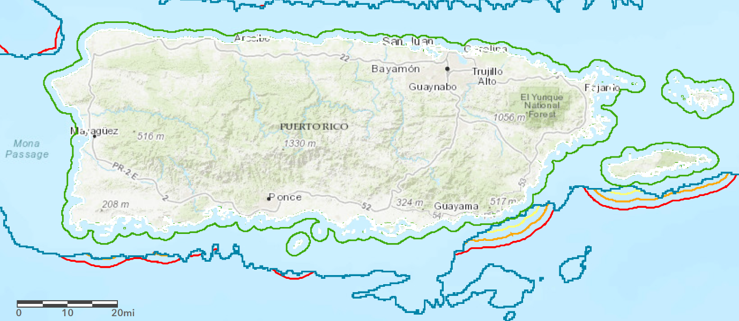

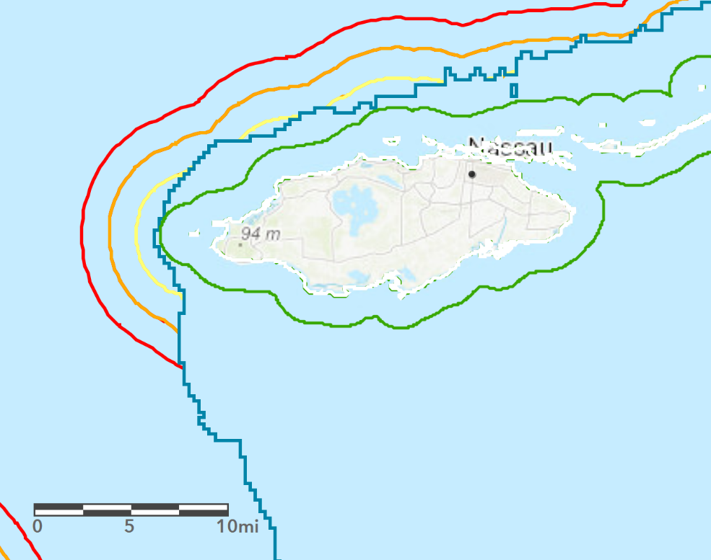

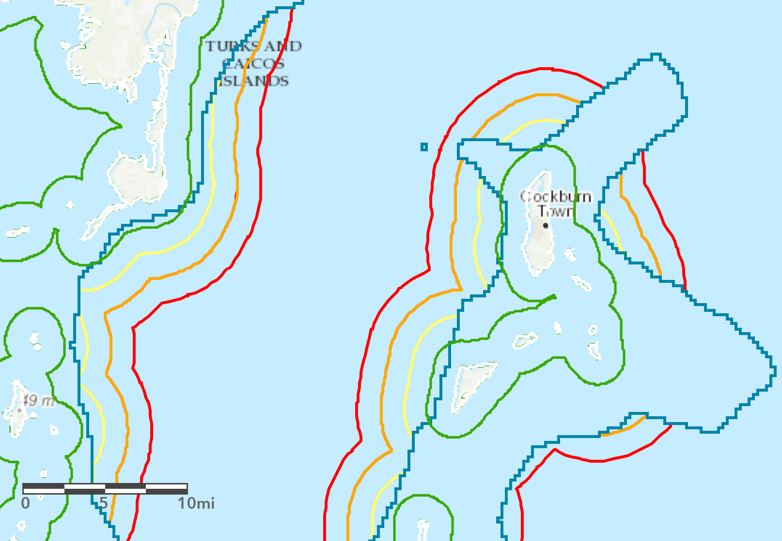

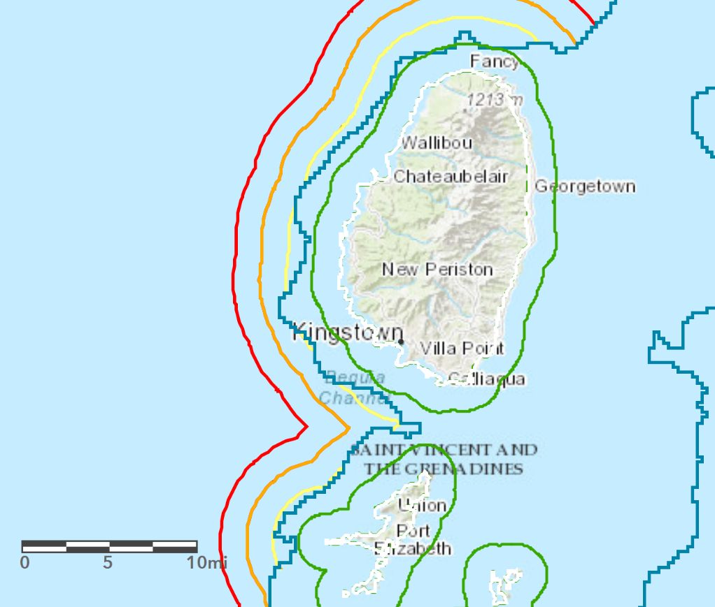

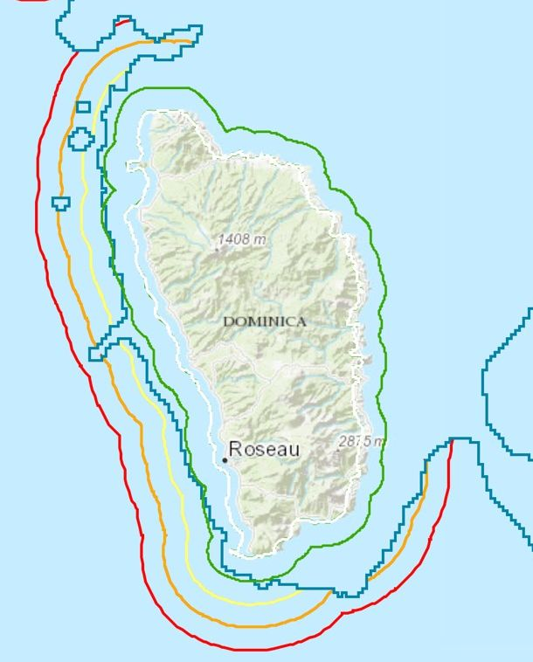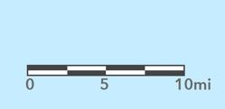

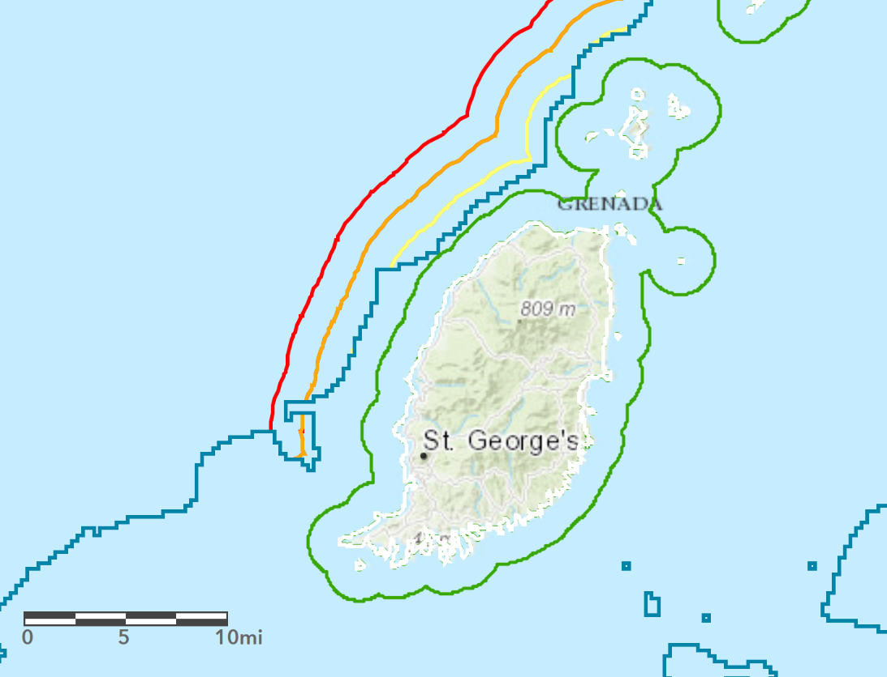

**Part III - Residual Load Duration Curves**

In Fig. SI1 the overall system residual demand is shown for a situation in which VRE + dispatchable power + storage is not able to meet demand during many hours of the year. Parameters are chosen as: Peak demand, 37.7 MW; solar pv capacity, 50 MW; wind capacity, 24 MW; dispatchable capacity, 15 MW; battery storage capacity, 100 MWh. It is useful to look at the results of the model in terms of load duration and residual load duration curves (LDC and RLDC) as these show at a glance the contributions of VRE, dispatchable power and storage to satisfying overall demand. In Fig. SI2 the top curve (orange) represents the system load, but now sorted from its highest to its lowest value during the year. Therefore the x-axis does not represent a sequence in time, but rather a fraction of the year during which the load is larger than a given amount. Likewise, the second curve (blue) represents VRE subtracted from the load for each hour, *then* sorted from highest value to lowest value. The gray curve in Fig. yyy gives the sorted remainder of both dispatchable power and VRE subtracted from the load, and finally, the yellow curve includes storage, also sorted after being subtracted for each hour of the year.

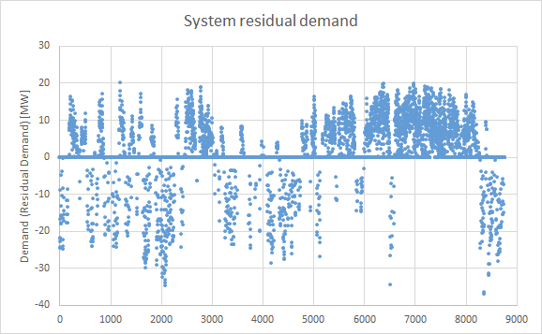

Figure - Residual load throughout all hours of the representative year

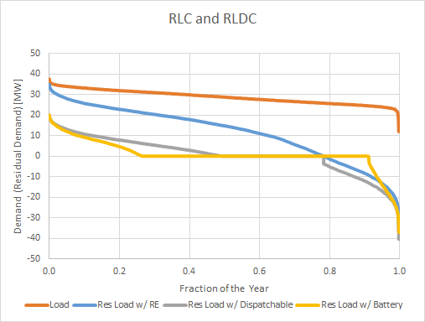

Figure - Load duration curve (orange) and residual load duration curves (RLDCs) considering variable renewable energy (VRE) only (blue), VRE + dispatchable renewable (gray) and including battery storage (yellow)

Comparing Figs. SI1 and SI2 we see in the former that the maximum value is reached at 20MW for a very few hours of the year; this is represented in Fig. SI2 by that same value at the left-hand edge of the traces in the yellow and gray curves. Negative values in both Fig. SI1 and Fig. SI2 represent overproduction of VRE during a fraction of hours, and that the yellow curve extends further to the right (fewer remaining hours) and to the left compared to the gray curve is a reflection of the fact that storage enables the system to take up a certain amount of overproduction (right-hand end of curve) and use it for some fraction of hours when demand exceeds total production of both VRE and dispatchable power, thus shifting the left-hand end of the yellow curve further to the left compared to the gray curve. The ideal outcome is to flatten the yellow curve to zero with a combination of VRE, dispatchable power and storage, while having a minimum of hours with excess generation (*i.e.* negative values of the RLDC).

In Fig. SI3 another limiting case is shown, with 37 MW peak demand, 110 MW of solar pv capacity, 90 MW of wind capacity, 10 MW of dispatchable capacity, 1000 MWh of battery storage. The combination of technologies is chosen to (very nearly) eliminate unserved demand on an hourly basis throughout the year. However, with very little dispatchable power available, a large amount of battery storage is needed, which remains nearly fully-charged In this case, the demand is met at all hours (perhaps with the exception of a very small number within the limits of standard grid operating parameters) as shown in the upper panel. The battery state of charge is shown for this case in the lower panel; one sees that the battery is nearly always in a state of fully charged capacity. Only for a relatively short period of a few days, shown in the lower panel, and as a time series through the year, is the full capacity of the battery necessary (around hours 7200-7300, at the end of October). In this case, without sufficient dispatchable capacity, there is both significant curtailment of VRE (~45% of total generation) and the need for investment in large battery capacity.

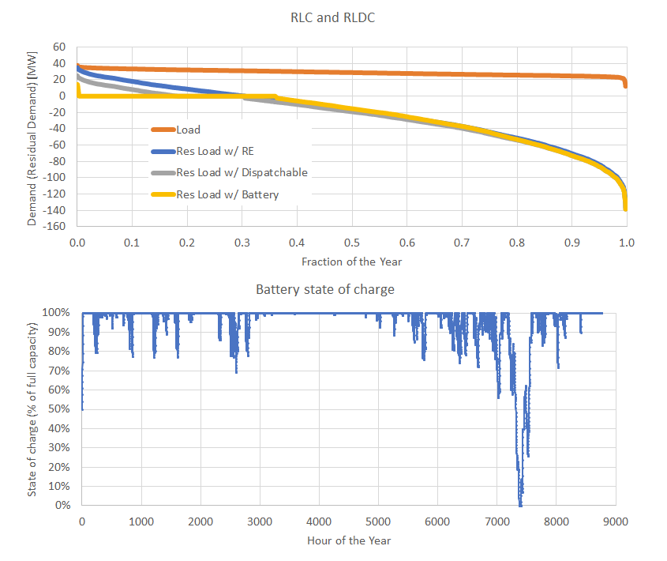

Figure - (Top) RLDC as in the previous figure, but for a system with relatively low dispatchable renewable energy capacity; demand is satisfied for very nearly all hours. (Bottom) Battery state of charge throughout the year is such that the system is usually fully charged; a large battery capacity is necessary in the absence of dispatchable power capacity, although that full battery capacity is needed for only very few hours of the year.